|  |  |  |  |
| --- | --- | --- | --- |
| Description: Description: S:\AdminShared\All Staff\1 College Logo's\Baldivis_Logo_colour.jpgName: | \_\_\_\_\_\_\_\_\_\_\_\_\_\_\_\_\_\_\_\_\_\_\_\_\_\_\_\_\_\_\_\_\_\_\_\_\_\_\_\_\_\_\_\_\_\_\_\_\_\_\_ | | Date: *\_\_\_\_\_\_\_\_\_\_\_* |
|  | **Year 11 Applications**  **Test 4, 2018**  **Topics –**  **Measurement** | | 55  = % |
| **Total Time:** | ***60*** *minutes* |  | |
| **Total Reading:** | *5**minutes* |
| **Total Working:** | *55**minutes* |
| **Weighting:** | *4% of the year* |
| **Equipment:** | *SCSA Formula Sheet; 1 page notes (A4 one side,* ***Unfolded****), CASIO ClassPad; Scientific Calculator* | | |

1. **[4 marks]**

Dan wants to fence this area of his backyard for a vegetable garden.

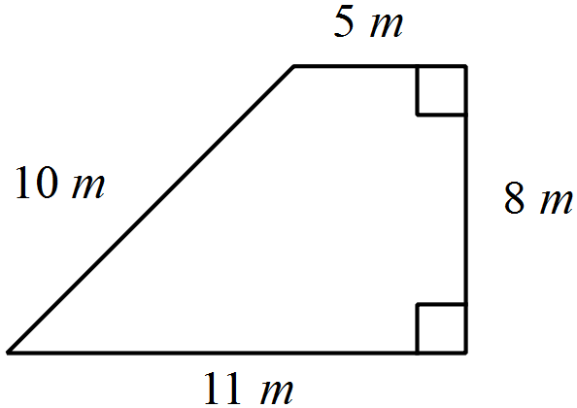

1. How many metres of fencing will Dan need?

(1 mark)

1. Dan wants to improve the soil by adding compost to the enclosed area. He intends adding one bag for every 20 m2. How many bags of compost does Dan need?

(3 marks)

1. **[2 marks]**

A can of Red Kidney Beans has a height of 11 cm and radius 3.5 cm. A label is to cover the entire curved surface of the tin can. What is the area that needs to be covered to the nearest cm?

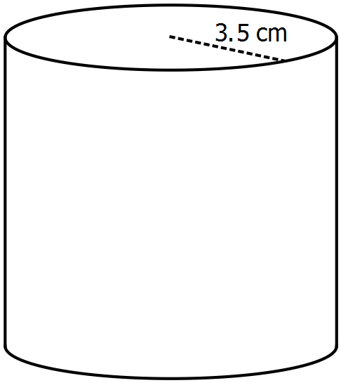

1. **[3 marks]**

A hollow cylindrical soakwell made with a solid concrete wall has the given measurements below. How many cubic metres of concrete was used to make the soakwell? Round to 2 decimal places.

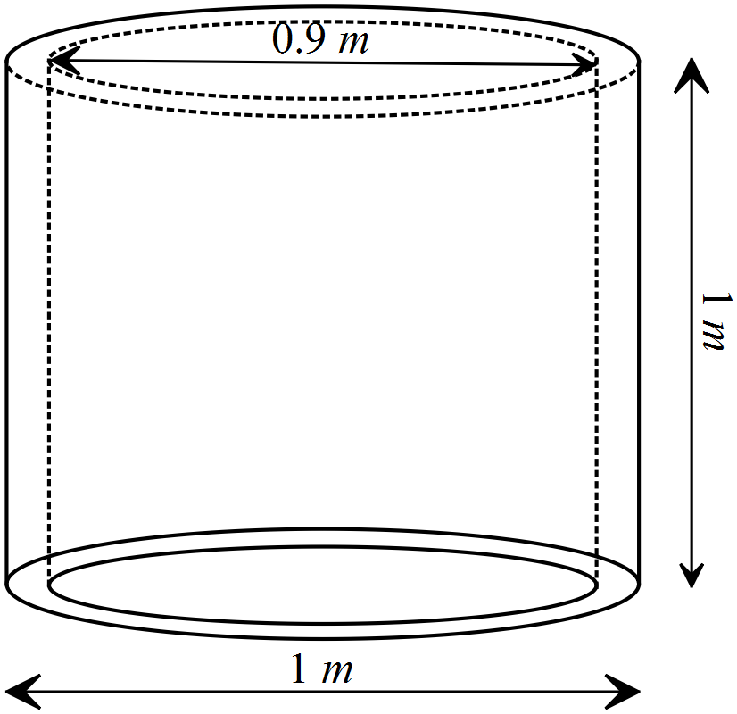

1. **[6 marks]**

Cain has a tent which, when erected is in the shape of a square pyramid with the dimensions given in the diagram below.

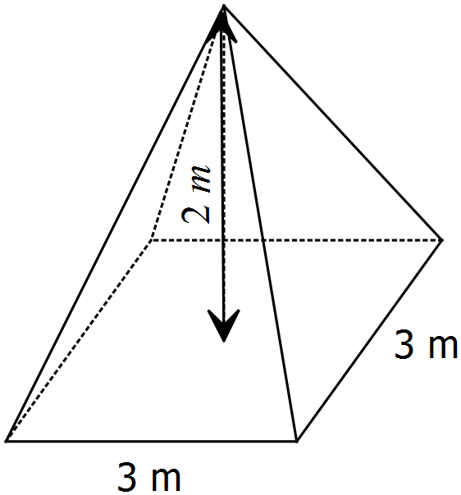

1. How much space is inside the tent when fully erect? (2 marks)
2. Cain’s tent is old and weathered. He decides to waterproof the outside of the tent. Ignoring any openings and extra allowances and not including the floor, calculate the area of fabric which needs water proofing. A 500 mL bottle of water proofing covers approximately 20 m2. How many bottles of water proofing does Cain need if two coats need to be applied? (4 marks)
3. **[5 marks]**

A narrow pool, designed for laps, is installed at the side of house. The pool is deeper at one end than the other.



1. The cost of a pool cover is $15.60 a square metre. Determine the cost of the cover for the lap pool.

(2 marks)

1. Determine the number of kilolitres of water required to fill the pool given one kilolitre = 1 m3.

(3 marks)

1. **[5 marks]**

The sketch below shows a solid wooden sphere with a radius of 7.5 cm.



(a) Calculate

(i) the volume of the sphere.

(1 mark)

(ii) the total surface area of the sphere.

(1 mark)

(b) The wooden sphere is sliced in half to create two hemispheres. Calculate

(i) the volume of one of the hemispheres.

(1 mark)

(ii) the total surface area of one of the hemispheres.

(2 marks)

1. **[3 marks]**

To water lawn you can use a reticulation system. Reticulation sprinklers are available in a variety of coverages based on the radius. Sprinklers spread water in a circular pattern. The brand ‘POPE’ have a 50mm pop up sprinkler that can cover a full circle a maximum of 4 metres radius, as shown below.

A full circle sprinkler distributes 12 L/min.

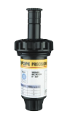

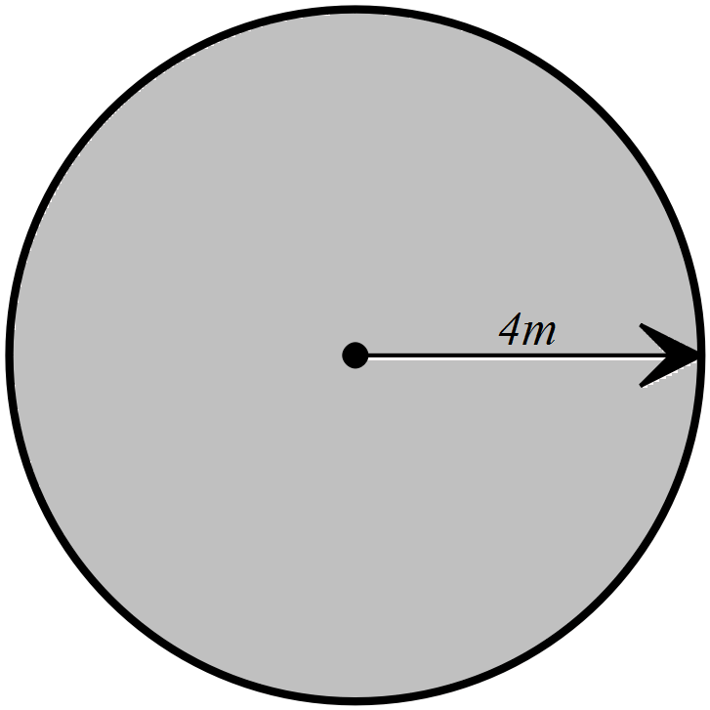

POPE. (2016). Sprinkler. Retrieved 17 February, 2016, from

http://www.popeproducts.com.au/media/11117/lawn-pop-up-guide.pdf

1. What is the maximum area the lawn sprinkler can cover?

(1 mark)

1. Occasionally sprinklers can get blocked and not work correctly. The shaded area below shows a sprinkler watering only the shaded area due to the sprinklers nozel being blocked. What is the maximum area of lawn the sprinkler is covering?

(2 marks)

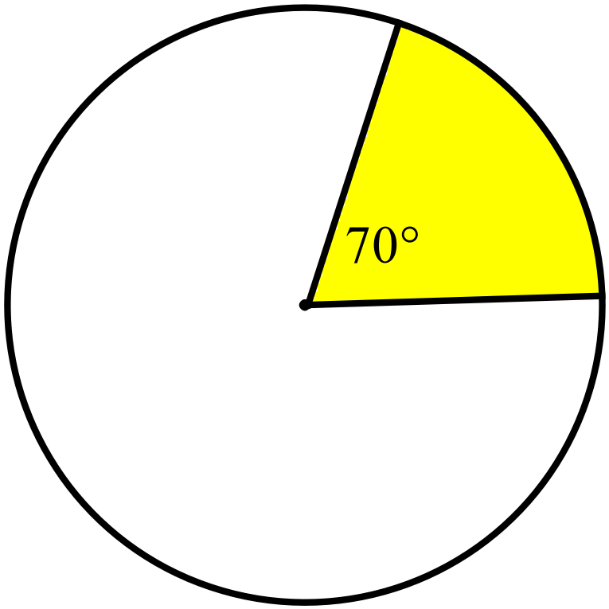

1. **[7 marks]**

A rectangular prism measuring 30cm by 40 cm by 8cm has a circular hole bored through its centre from one side to the other as shown below.

**

1. What was the volume of the rectangular prism before the circular hole was bored?

(1 mark)

After the circular hole was bored, the volume of the remaining shape was half of the original volume.

1. Show with calculations that the radius of the circular hole must be 13.82cm, correct to 2 decimal places.

(2 marks)

1. Determine the total surface area of the solid that remains after the circular hole is bored as shown above, correct to the nearest cm2.

(4 marks)

1. **[8 marks]**

A hollow wheat silo is to be constructed from metal. It has a circular base which is 6.40 m in diameter. On top of the base is a cylinder with a cone on top, as shown below.

(Note: this diagram is not to scale.)



1. Determine the maximum volume of wheat that this silo could hold if it was filled to the top of the cone.

(3 marks)

1. Before the surface area can be determined, the slant height of the cone top needs to be calculated. Show that the slant height is 3.5 m to **one (1)** decimal place.

(2 marks)

1. Given that the slant height of the cone top is **3.5 m**, determine the amount of metal (in square metres) required to build the silo.

(3 marks)

1. **[12 marks]**

The diagram below shows the dimensions of a paved area (hatched shading) that is adjacent to a circular pool of radius 4 m.

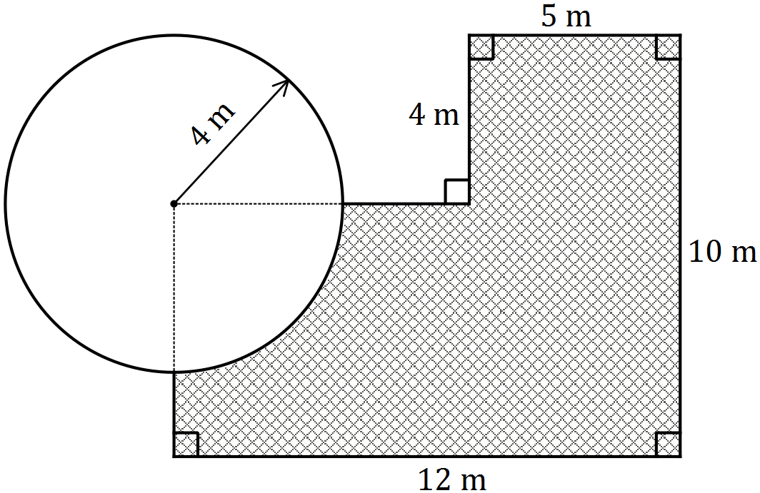

1. Determine the length of the perimeter of the paved area to 2 decimal places.

(3 marks)

1. Determine the area of the paving to 2 decimal places.

(4 marks)

1. The paving slabs used to pave the area are 50cm x 40cm. Determine the number of slabs that will need to be purchased to pave the area.

(3 marks)

1. The slabs need to be purchased in boxes of 20 and a box costs $24.95. How much will the paving cost?

(2 marks)